**Step** 1: Java should be installed in your machine.

**Step 2**: Please check out the code from the provided Online code repository. “**Pactera”** is the folder name.

**Step 3**: Under Pactera folder, there is a folder named “**apache-ant-1.9.4**”.

1. Go to my system properties (WinKey + Pause), select “Advanced” tab, and the "Environment Variables" button, then adding or selecting the *PATH* variable in the System variables with the value

Path of ant bin under downloaded Pactera folder like **E:\Testing Tools\Project**\Pactera\apache-ant-1.9.4\bin

When we are adding the ant path to the existing path, use the separator “;” as shown in the screenshot.

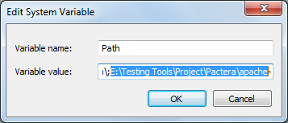

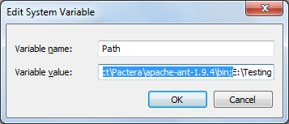

1. Create a variable under System Variables with Variable name “Ant_HOME” and Variable value with path of the ant under downloaded Pactera folder etc; “E:\Testing Tools\Project\Pactera\apache-ant-1.9.4”

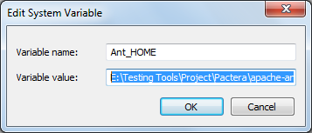

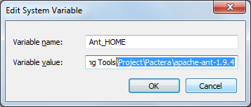

**Step 4**: Open the command prompt and change the directory to your downloaded Pactera folder as shown in the screenshot below.

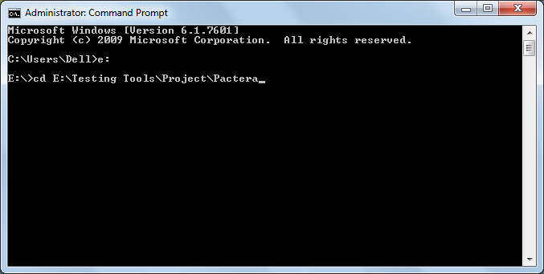

* Give “ant” command as shown below.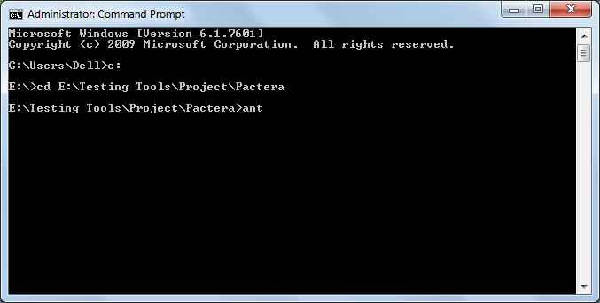

Build should be successful

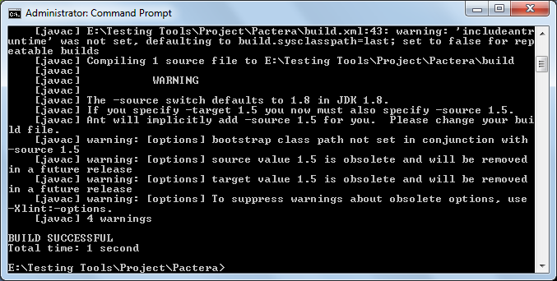

* Give “ant compile” command to compile the java files as shown below. 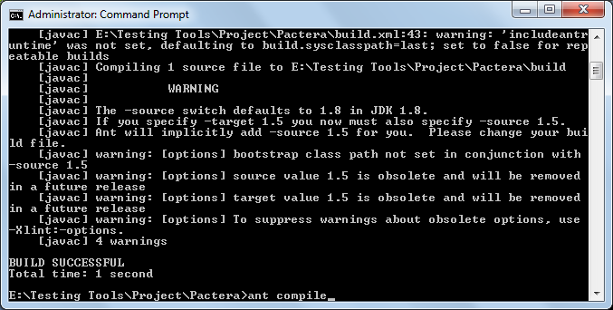

Build should be successful

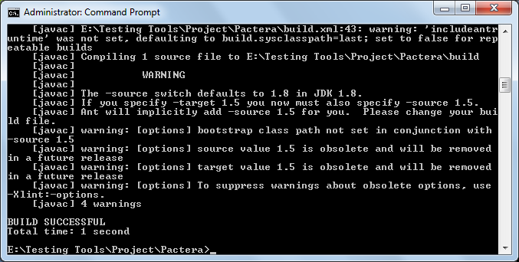

* Give “ant run” command for running the files as shown below.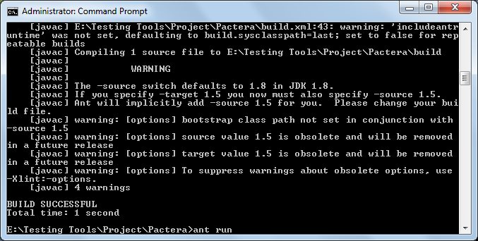

Then, it runs the files and do the “test automation” search in Pactera site automatically and shows you the result. As per the code, web application will be closed automatically after 40 seconds after showing you the result. It provides the report in command prompt as below.

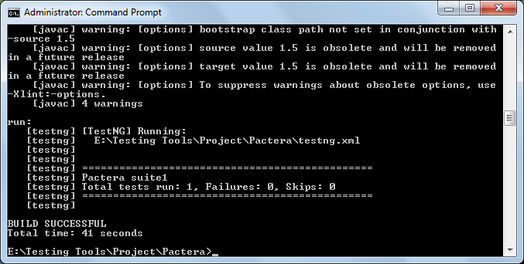

* Give “ant xslt” command to get the customized user friendly report as below.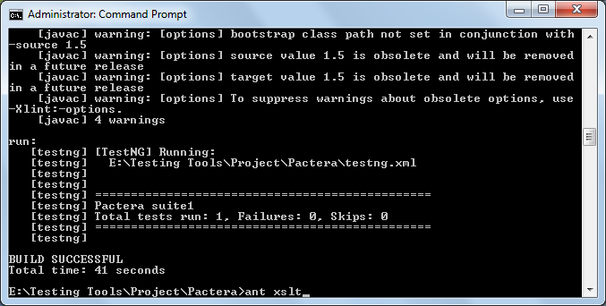

Build should be successful again.

Then you can view the report at the below web link by replacing E:/Testing%20Tools/Project/ with your downloaded path of Pactera folder

file:///**E:/Testing%20Tools/Project**/Pactera/XSLT_Reports/output/index.html

you can get the report as shown in the below screenshot.

